**INTERNATIONAL SCHOOL – VIETNAM NATIONAL UNIVERSITY**

Location: 144 Xuân Thuy, Cau Giay, Hanoi

Hotline: (024).3754.8065 &(024) 3672.0999

**Guidance**

**subject registration**

*Hanoi*

**TABLE OF CONTENTS**

1. Log in 3

2. Change password 3

3. Register for subjects 5

3.1. Program curriculum 5

3.2. Registration 5

1. ACCOUNT
2. Log In

* Access: sv.isvnu.vn
* To check personal information, timetable, exam schedule, subject registration and debt.

Log in

* + Fill student code
  + Fill password
  + Click  to log in
  + Users can see school notifications even without logging in

1. Change password

* Use this function to change password.
* Fill the old and new password 🡪 Save (Lưu)

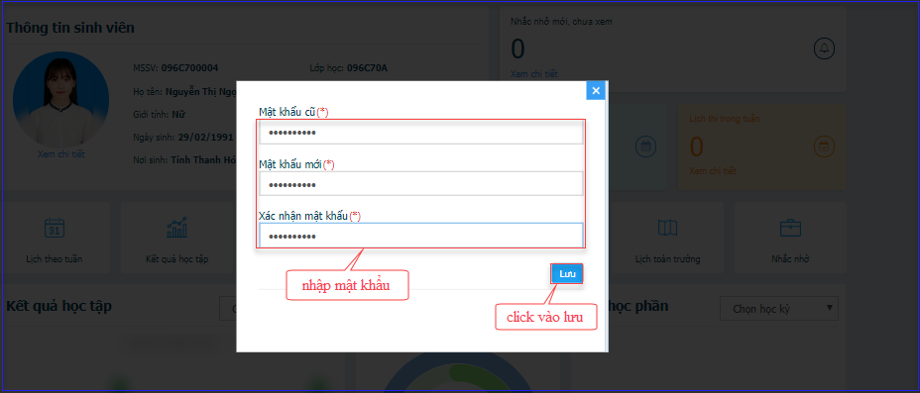

1. Register for subjects
   1. **Program curriculum (Chương trình khung)**

This function helps students check the program curriculum to facilitate the choice of subject registration.

- Access the school website [**http://www.is.vnu.edu.vn/en/**](http://www.is.vnu.edu.vn/en/) 🡪 Select “Academic” 🡪 Select Program 🡪 Click “Program Structure” 🡪 Select Program Structure with the corresponding batch.

* 1. **Registration**

*Step 1****:*** Select semester (Chọn đợt đăng ký)

Students select the semester to register as the personal study progress and the academic schedule of OAA (Office of Academic Affairs)

*Step 2*: Select the type of registration:

* *New learning (Học mới)*: Select “Học mới” to register for the subjects for the first time.
* *Relearning (Học lại)*: Select “Học lại” to register for failed subjects.
* *Grade improving learning (Học cải thiện điểm)*: Select “Học cải thiện to register for subjects that students passed but still want to get higher grade.

*\* Notes:*

*- Prerequisite subjects*: Students have to pass these subjects to be able to register for other following ones.

*- Equivalent subjects:* Studentcan register for a subject instead of another.

*Step 3*: Select the subjects:

* Click the subject to register
* Subjects with the symbol  in “Bắt buộc” Column (Compulsion): is compulsory subjects that students need to pass in Program curriculum.
* Subjects with the symbol in “Bắt buộc” Column: is elective subjects. Students can select any subjects as long as with the same amount of credits in each module of program curriculum.

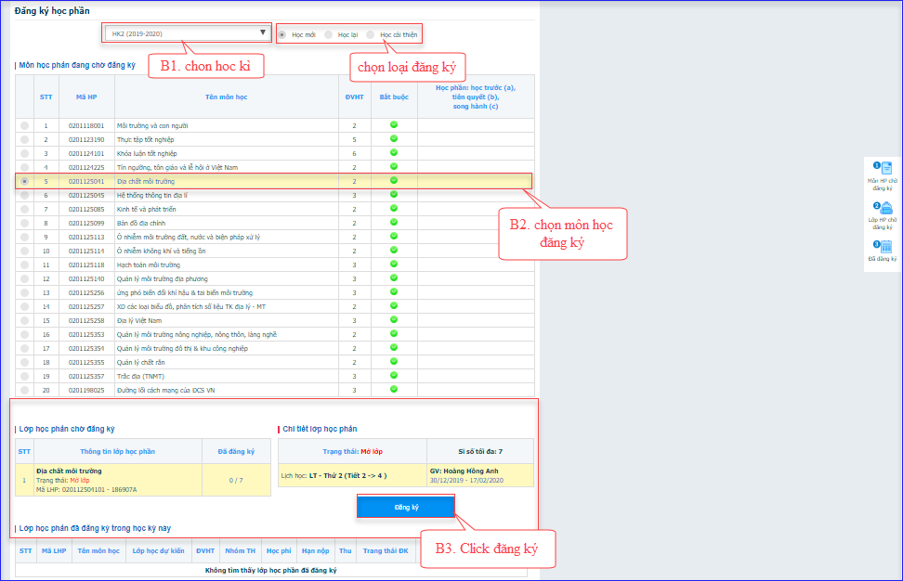

*Step 4****:*** Select the classes

- Maximum quantity (Sĩ số tối đa): the limited number of students can register for a class

- Registered quantity (Sĩ số đăng ký): Number of students registered for the class.

- Class Status (Trạng thái LHP): Students can only register for class if the class status displays Open (Mở lớp) or Only Register (Chỉ đăng ký).

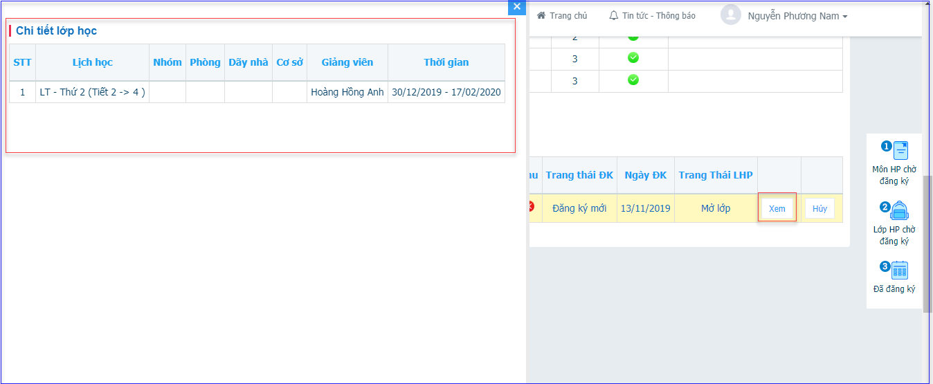

* After the successful registration, students can review the list of registered subjects

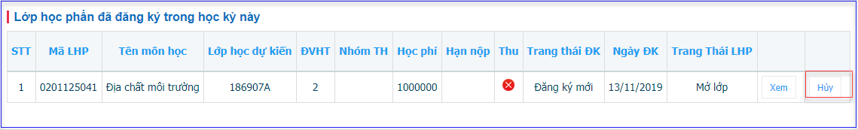

* Button : To cancel the registered subjects
* Students are not permitted to cancel the subject registered in the following cases:
  + Class status (Trạng thái LHP): Only register (Chỉ đăng ký) and Locked (Đã khóa)
  + Tution fee of class was paid

1. FREQUENT SITUATION AND SOLUTIONS
   1. Situation 1: I cannot find the subject that I need to register.

There are some causes as follows:

Cause 1: The subjects is not included in academic schedule of the semester.

*Solution*: Students contact OAA to request for opening that subject.

Cause 2: Students learnt the subject in previous semester but failed.

*Solution*: Students select “Relearn” (Đăng ký học lại) to go to relearning registration page.

Cause 3: Student passed the subjects in the previous semester and want to improve grades in this semester.

*Solution*: Students select “Grade improving registration” (Đăng ký học cải thiện)

b. Situation 2: When I make the subject registration, Portal notifies “Tution fee plan is unavailable” (Chưa thiết lập kế hoạch thu học phí)

Cause: Office of Planning – Finance has not set the tuition fee for the lớp khóa học sinh viên.

*Solution:* Students contact Office of Planning – Finance for support (providing the student code and the batch class)

c. Situation 3: When I select the semester, Portal notifies “The subject registration is unavailable in this semester” (Đợt này sinh viên không được đăng ký!)

Cause: Registration time is over or too early in the chosen semester. Students should wait for the announcement from OAA.

d. Situation 4: Portal warns the class overlaps with another registered.

Cause: Students are not permitted to register for classes whose times overlap. Please find other classes to register.

e. Situation 5: Portal notifies “You didn’t pass the subjects” (Môn học phần đã từng học nhưng không đạt)

Cause: Students registered for the subjects many times before (new learning, relearning, grade improving learning) but registration status is invalid. *Solution*: Students contact OAA for support.

1. SUPPORT INFO

Please contact Office of Academic Affairs, if you have any concerns about subject registration, program structure and academic results.