VIETNAM NATIONAL UNIVERSITY, HANOI | SOCIALIST REPUBLIC OF VIETNAM
INTERNATIONAL SCHOOL | Independence – Freedom – Happiness
No.: /TB-KQT | Hanoi, July 2021

ANNOUNCEMENT

About specialized major registration

for VNU program undergraduate, first time in 2021

Based on Program Curriculum approved by Vietnam National University, Hanoi and student’s learning progress, International School announces the schedule of specialized major registration for VNU program students, as follows:
1. Who can register:
All QH2019Q students who study the following majors: International Business, Management Information System and Business Data Analysis.
2. How to register:
Access Portal and register at https://sv.isvnu.vn/sinh-vien-dang-nhap.html.
3. Time:
From July 30, 2021 to August 01, 2021.
4. For assistance:
For any registration concerns, please leave your response at the link below:
https://docs.google.com/spreadsheets/d/1XX4_bemrLVQA3mLzFm1uDq9AGxJ8gJ1U/edit#gid=848122068
NOTE: Please carefully read the guidance on registration at the attached file.

Recipients:  - Dean (to report);  - Vice Dean Nguyen Quang Thuan (to report and direct);  - Students (to implement);  - Save: VT,ĐT, V(1). | P.P. DEAN  OFFICE OF ACADEMIC AFFAIRS  Phan Thi Ngoc Hoa

GUIDANCE ON REGISTRATION SPECIALIZED MAJOR
FOR VNU PROGRAM STUDENTS (1st time, 2021)

1. There are 02 times to register in the 3rd year of course (including one time for official registration and one time for adjustment, one semester apart each time.
2. Based on Program Curriculum and study advisor’s opinions, you decide to choose specialized major that is suitable for strength and career orientation.
- To see Program Curriculum: Access the website http://www.is.vnu.edu.vn/en/
-> Click ‘Academic’ tab -> Choose Program -> Click Program Structure
- Info of study advisor for corresponding classes: Be released before the registration day on Portal.
3. After selecting and registering, you will only can see the subjects of chosen specialized major. If you changes the specialized major, you will have to finish those new subjects. The finished subjects of old specialized major is not included in cumulative GPA.
4. Notes:
- If you do not make a registration on Portal, you will be automatically added in the class of the majority.
- After being divided into specialized majors, some subjects will not be available for every semester (depending on the number of students register to open/cancel classes).When choosing specialize major, please pay attention to this point to ensure learning progress as your plan.
- For programs organized by annual class, you will have to choose the specialized major selected by the majority of students.
5. How to register on Portal:
- On the Portal, the specialized major default is:
+ For International Business: Marketing.
+ For Management Information System: Information systems management.
+ For Business Data Analysis: Analytical models development
- If you want no change on specialized major, please do nothing to keep the default one.
- If you want to change, please follow the steps below:
Log in Portal

Registr-ation
Specialized Major Registrtion

Specialized Major
New class

Save

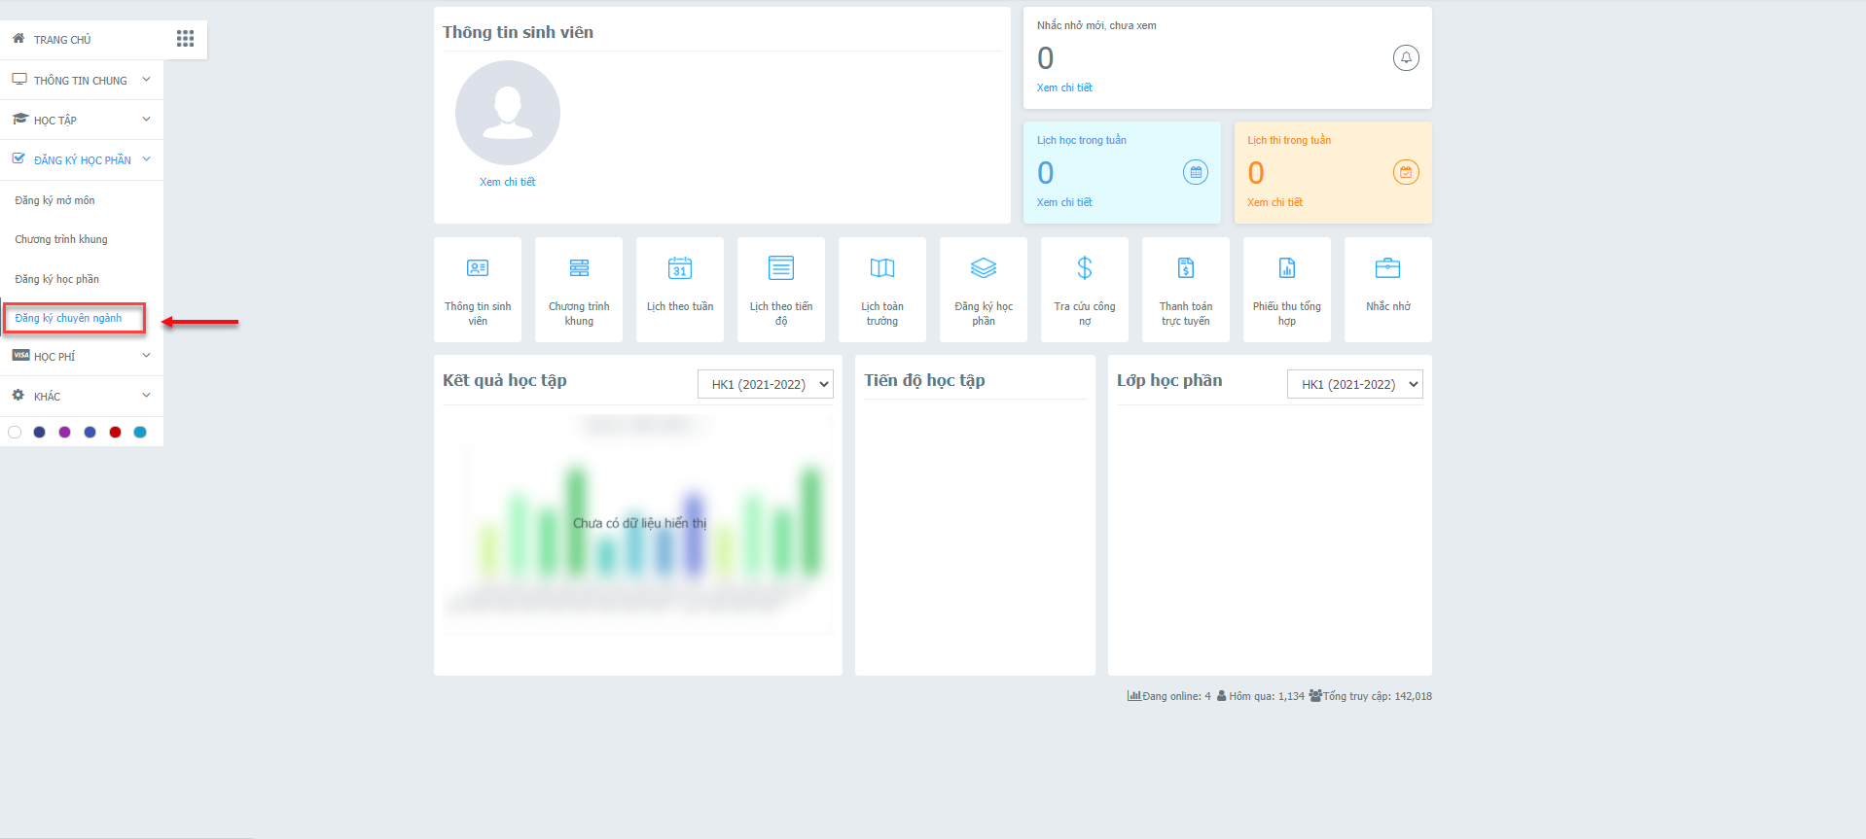

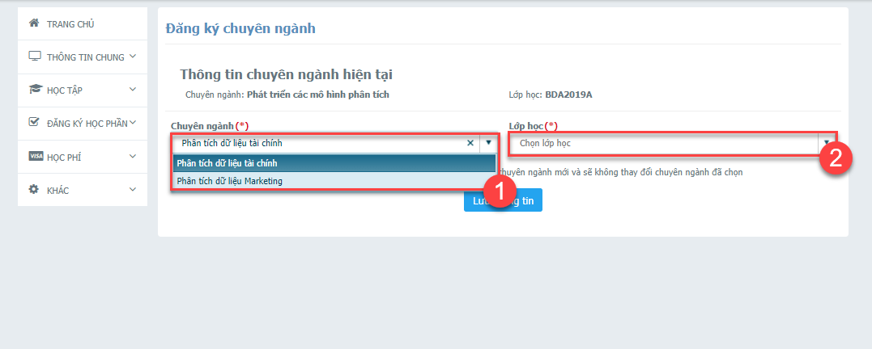

Note:
- When the registration time of specialized major begins, the screen will be displayed as the photo above. If it’s not the time to register, you will see the notification shown “You are not permitted to register for specialized major”.
- You can only register for specialized major once for each time of registration time.

Connversion Table for Classes based on specialized major on Portal
Original Class | New class based on specialized major
Original Class | Finance | Corporate Accounting | Information management in Finance | Information management in Marketing | Information management in Real Estate | Financial data analysis | Marketing Data Analysis
IB2019A | IB2019A 1 | IB2019A 2
IB2019B | IB2019B 1 | IB2019B 2
IB2019C | IB2019C 1 | IB2019C 2
IB2019D | IB2019D 1 | IB2019D 2
IB2019E | IB2019E 1 | IB2019E 2
IB2019G | IB2019G 1 | IB2019G 2
MIS2019A |  |  | MIS2019A 1 | MIS2019A 2 | MIS2019A 3
MIS2019B |  |  | MIS2019B 1 | MIS2019B 2 | MIS2019B 3
BDA2019A |  |  |  |  |  | BDA2019A 1 | BDA2019A 2

