VIETNAM NATIONAL UNIVERSITY, HANOI | SOCIALIST REPUBLIC OF VIETNAM
INTERNATIONAL SCHOOL | Independence – Freedom – Happiness
No.: /TB-TQT | Hanoi, July 2021

NOTIFICATION

About registering in-depth study of major

for VNU program undergraduate, first time in 2022

Based on Program Curriculum approved by Vietnam National University, Hanoi and student’s learning progress, International School notifies the schedule of registering in-depth study of major for VNU program students, as follows:
1. Who can register:
- All QH2020Q students majoring in International Business (IB), Management Information System (MIS) or Business Data Analysis (BDA).
- All QH2021Q students majoring in English Language (Business – IT)
2. How to register:
Access Portal and register at https://sv.isvnu.vn/sinh-vien-dang-nhap.html.
For international students, please ask Ms. My for assistance.
3. Time:
From May 16, 2022 to May 19, 2022.
4. For assistance:
For any registration concerns, please contact Ms. My via email myntv@isvnu.vn or Tel: 0986 891 391.
NOTE: Please carefully read the guidance on registration at the attached file.

P.P. RECTOR
OFFICE OF ACADEMIC AFFAIRS

(Signed)

Phan Thi Ngoc Hoa

INSTRUCTION ON REGISTERING IN-DEPTH STUDY OF MAJOR
ON PORTAL FOR VNU PROGRAMME STUDENTS (1st time, 2021)
1. School opens 02 registration phases in the 3rd year of course (including one time for official registration and one time for adjustment, one semester apart each time)
2. Based on Program Curriculum and academic advisor’s opinions, students make a decision on in-depth study of major that match your own strength and career orientation.
- To see Program Curriculum: Access the website https://truongquocte.edu.vn/
-> Click ‘Academic’ tab -> Choose Your Program -> Click Program Structure
3. After registration, Portal will only show the subjects of chosen in-depth study of major. Any changes of in-depth study of major will lead to new subjects to take. The passed subjects of previous in-depth study are not included in final cumulative GPA.
4. Notes:
- Automatic registration in the class of majority will be applied to students who do not register on Portal.
- Depending on the number of students register for subjects of each in-depth study of major, some subjects will not be available for every semester. The selection of the minority could cause the discontinued learning process.
- For programmes organized as annual class, the selection of in-depth study of major is based on the majority
5. How to register on Portal:
- The default selection on Portal is shown, as follow:
+ For International Business: Marketing.
+ For Management Information System: Information Systems Management.
+ For Business Data Analysis: Analytical Models Development
+ For English Language (Business – IT): Business – Interpretation and Translation for Business – IT.
- For no change of in-depth study, please skip this step
- For the change of in-depth study, please follow the steps below:

Log in Portal

Registr-ation
In-depth study of major Registra-
tion

In-depth study of major

New class

Save

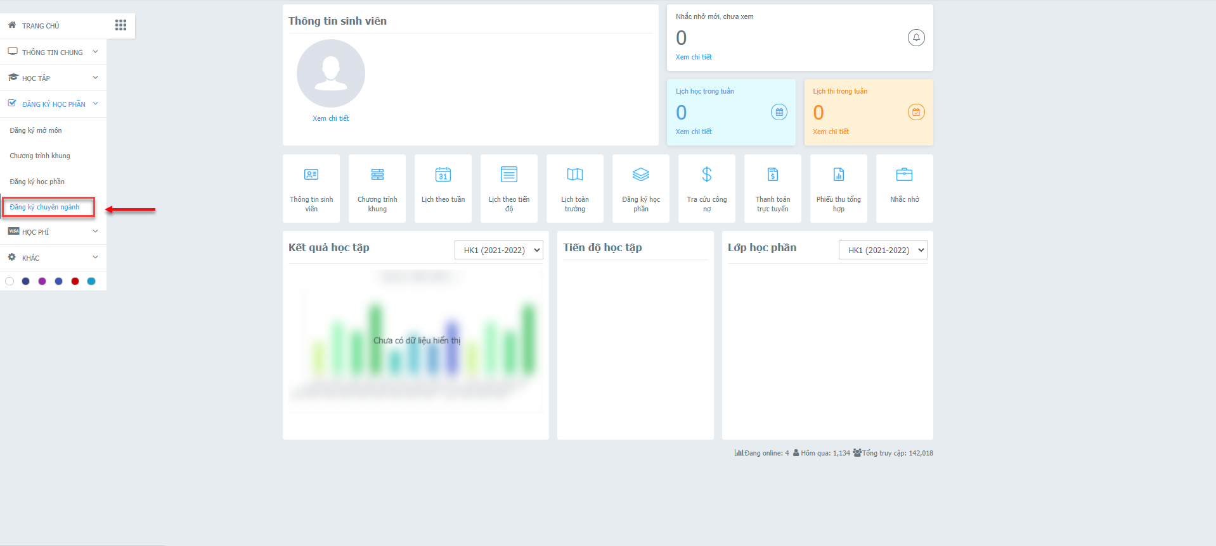

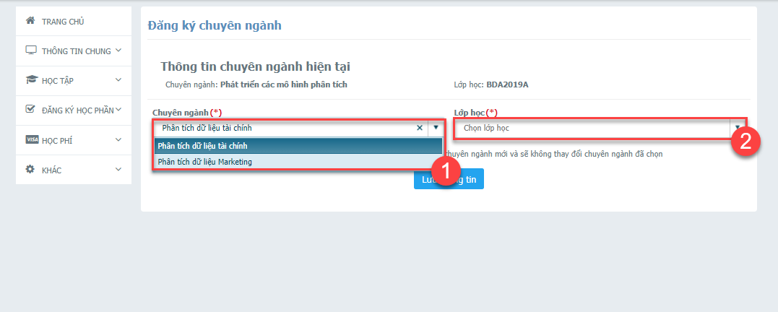

Note:
- In the opening time of in-depth study of major registration, the Portal is only displayed as the photo above. Out of the registration time, the notification shown “You are not permitted to register for in-depth study of major”.
- Student is allowed to register once for each time of registration time.

Conversion Table for Classes based on in-depth study of major shown on Portal
- English Language (Business – Information Technology)
In-depth study of major | Original Class | New class based on in-depth study of major | Original Class | New class based on in-depth study of major
Kinh doanh - Giảng dạy tiếng Anh trong lĩnh vực kinh doanh - CNTT | BEL2021A | BEL2021A 1 | BEL2021B | BEL2021B 1
Kinh doanh - Đối ngoại trong lĩnh vực kinh doanh - CNTT | BEL2021A | BEL2021A 2 | BEL2021B | BEL2021B 2
Kinh doanh - Nghiên cứu ngôn ngữ học ứng dụng | BEL2021A | BEL2021A 3 | BEL2021B | BEL2021B 3
Công nghệ thông tin – Biên phiên dịch trong lĩnh vực kinh doanh – CNTT | BEL2021A | BEL2021A 4 | BEL2021B | BEL2021B 4
Công nghệ thông tin - Giảng dạy tiếng Anh trong lĩnh vực kinh doanh - CNTT | BEL2021A | BEL2021A 5 | BEL2021B | BEL2021B 5
Công nghệ thông tin - Đối ngoại trong lĩnh vực kinh doanh - CNTT | BEL2021A | BEL2021A 6 | BEL2021B | BEL2021B 6
Công nghệ thông tin - Nghiên cứu ngôn ngữ học ứng dụng | BEL2021A | BEL2021A 7 | BEL2021B | BEL2021B 7

- International Business, Management Information System, Business Data Analysis
Original Class | New class based on in-depth study of major
Original Class | Finance | Corporate Accounting | Information management in Finance | Information management in Marketing | Information management in Real Estate | Financial data analysis | Marketing Data Analysis
IB2020A | IB2020A 1 | IB2020A 2
IB2020B | IB2020B 1 | IB2020B 2
IB2020C | IB2020C 1 | IB2020C 2
IB2020D | IB2020D 1 | IB2020D 2
IB2020E | IB2020E 1 | IB2020E 2
IB2020F | IB2020F 1 | IB2020F 2
IB2020G | IB2020G 1 | IB2020G 2
MIS2020A |  |  | MIS2020A 1 | MIS2020A 2 | MIS2020A 3
MIS2020B |  |  | MIS2020B 1 | MIS2020B 2 | MIS2020B 3
MIS2020C |  |  | MIS2020C 1 | MIS2020C 2 | MIS2020C 3
BDA2020A |  |  |  |  |  | BDA2020A 1 | BDA2020A 2
BDA2020B |  |  |  |  |  | BDA2020B 1 | BDA2020B 2
BDA2020C |  |  |  |  |  | BDA2020C 1 | BDA2020C 2

