VIETNAM NATIONAL UNIVERSITY, HANOI | SOCIALIST REPUBLIC OF VIETNAM
INTERNATIONAL SCHOOL | Independence – Freedom – Happiness
No.: /TB-TQT | Hanoi, October 2021

ANNOUNCEMENT

About registering in-depth study

for VNU undergraduate students in 2022 (2nd phase)

Based on Program Curriculum approved by Vietnam National University, Hanoi and the student’s learning progress, International School (VNU-IS) informs students the schedule of registering in-depth study for VNU program students, as follows:
1. Who can register:
1.1. Register the in-depth study for the 1st time
- All QH2021Q undergraduate students majoring in International Business (IB), Management Information System (MIS), Business Data Analysis (BDA) and Automation and Informatics (AAI).
1.2. Change and finalize the in-depth study selection
- All OH2020Q students majoring in International Business (IB), Management Information System (MIS), Business Data Analysis (BDA)
- All QH2021Q students majoring in English Language (Business – IT).
2. How to register:
Access Portal and register at https://sv.isvnu.vn/sinh-vien-dang-nhap.html.
For International Students, please ask Ms. My for assistance.
3. When to register:
From 4th to 7th of November 2022.
4. For assistance:
For any registration concerns, please contact Ms. My via email mynv@vnuis.edu.vn or Tel: 0986 891 391.
Note: Please carefully read the instruction on registration at the below attached document.
P.P. RECTOR
OFFICE OF ACADEMIC AFFAIRS

(Signed)

Phan Thi Ngoc Hoa
INSTRUCTION ON REGISTERING IN-DEPTH STUDY OF MAJOR
ON PORTAL FOR VNU PROGRAMME STUDENTS (1st time, 2021)
1. School opens 02 registration phases in the 3rd year of course (including the official registration and the adjustment, one semester apart each time)
2. Based on Program Curriculum and academic advisor’s opinions, students make a decision on in-depth study that appropriate your own strength and career orientation.
- To see Program Curriculum: Access the website https://truongquocte.edu.vn/
-> Click ‘Academic’ tab -> Choose Your Program -> Click Program Structure
3. After registration, Portal will only show the subjects of chosen in-depth study of major. Any changes of in-depth study of major will lead to new subjects to take. The passed subjects of previous in-depth study are not included in final cumulative GPA.
4. Notes:
- Automatic registration in the class of majority will be applied to students who do not register on Portal.
- Depending on the number of students register for subjects of each in-depth study of major, some subjects will not be available for every semester. The selection of the minority could cause the discontinued learning process.
- In-depth knowledge class is normally opened when there is a minimum number of 40 students to ensure the constant organization of the knowledge module. If the number of registered students is less than 40 for other in-depth study modules, the organisation will depend on the principle of the majority.
- For programmes organized as annual class, the selection of in-depth study of major is based on the majority
5. How to register on Portal:
- The default selection on Portal is shown, as follow:
+ For International Business: Marketing.
+ For Management Information System: Information Systems Management.
+ For Business Data Analysis: Analytical Models Development
+ For Automation and Informatics: Automation
- For no change of in-depth study, please skip this step
- For the change of in-depth study, please follow the steps below:

Log in Portal

Registr-ation
In-depth study of major Registra-
tion

In-depth study of major

New class

Save

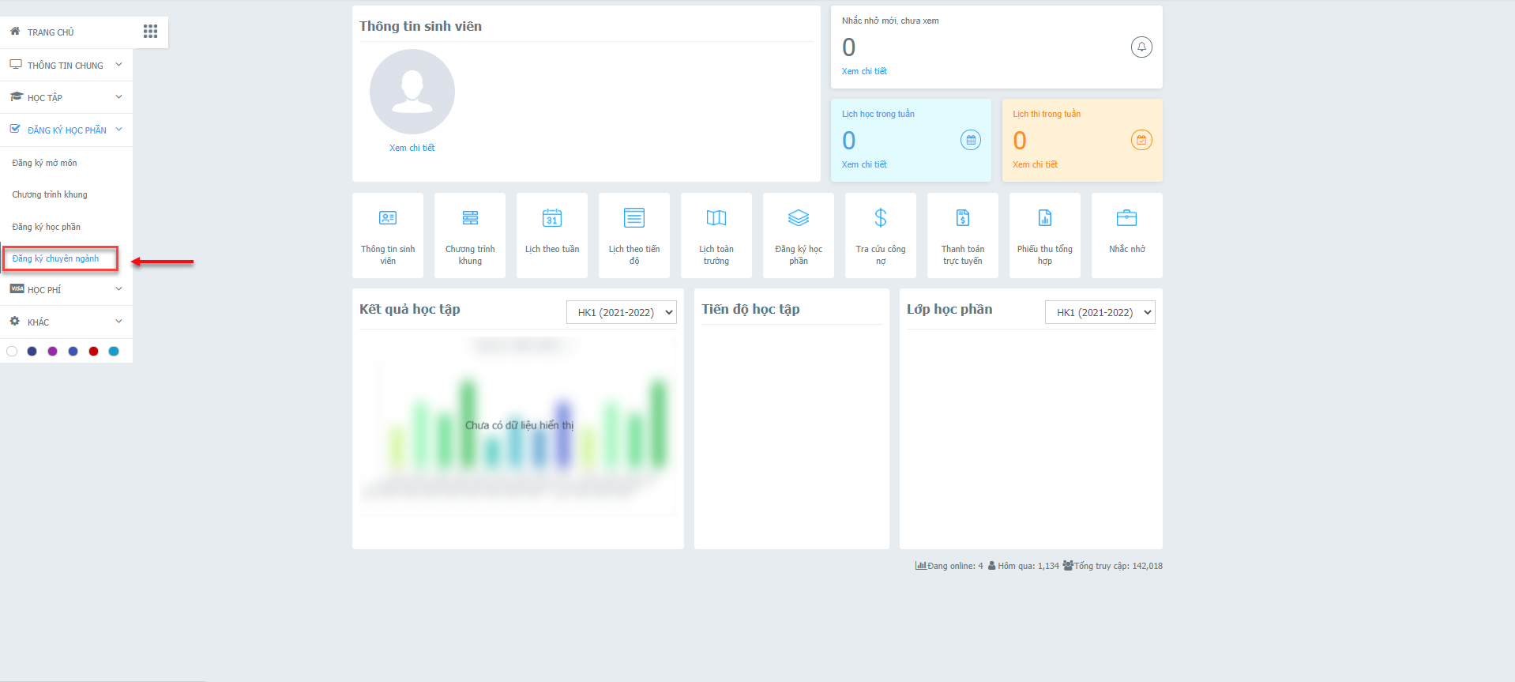

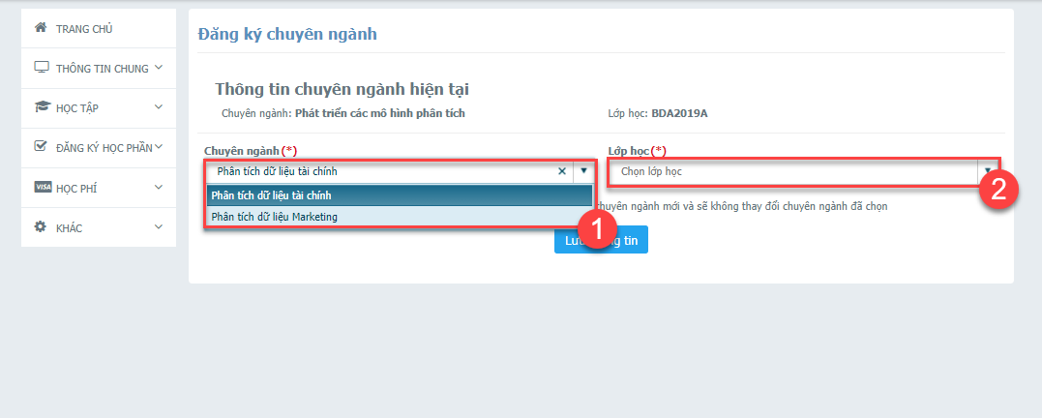

Note:
- In the opening time of in-depth study of major registration, the Portal is only displayed as the photo above. Out of the registration time, the notification shown “You are not permitted to register for in-depth study of major”.
- Student is allowed to register once for each time of registration time
International Business, Management Information System, Business Data Analysis, Automation and Informatics name class
on Portal after selecting In-depth Study
Original Class | New class based on in-depth study of major
Original Class | Finance | Corporate Accounting | Information management in Finance | Information management in Marketing | Information management in Real Estate | Financial data analysis | Marketing Data Analysis | Automation | Informatics
IB2021A | IB2021A 1 | IB2021A 2
IB2021B | IB2021B 1 | IB2021B 2
IB2021C | IB2021C 1 | IB2021C 2
IB2021D | IB2021D 1 | IB2021D 2
MIS2021A |  |  | MIS2021A 1 | MIS2021A 2 | MIS2021A 3
MIS2021B |  |  | MIS2021B 1 | MIS2021B 2 | MIS2021B 3
BDA2021A |  |  |  |  |  | BDA2021A 1 | BDA2021A 2
BDA2021B |  |  |  |  |  | BDA2021B 1 | BDA2021B 2
BDA2021C |  |  |  |  |  | BDA2021C 1 | BDA2021C 2
AAI2021A |  |  |  |  |  |  |  | AAI2021A 1 | AAI2021A 2
AAI2021B |  |  |  |  |  |  |  | AAI2021B 1 | AAI2021B 2

