VIETNAM NATIONAL UNIVERSITY, HANOI | SOCIALIST REPUBLIC OF VIETNAM
INTERNATIONAL SCHOOL | Independence – Freedom – Happiness
No.: /TB-TQT | Hanoi, October 2023

ANNOUNCEMENT

About registering for the in-depth study (1st time, 2024)
Pursuant to the Program Curriculum approved by Vietnam National University, Hanoi, the student’s learning progress and the result of meeting with academic advisors, International School (VNU-IS) informs students of the schedule of registering in-depth study for VNU program students (1st time, 2024), as follows:
1. Who can register:
1.1. Register the in-depth study for the 1st time
- QH2023Q undergraduate students majoring in English Language (BEL)
1.2. Adjust and finalize the in-depth study selection (if any)
- QH2022Q students majoring in International Business (IB), Accounting, Analyzing and Auditing (AC), English Language (BEL) (select the in-depth study in specialized knowledge module), Management Information System (MIS), Automation and Informatics (AAI), Business Data Analysis (BDA), Applied Information Technology (AIT), Fintech and Digital Business (FDB), Industrial System Engineering and Logistics (ISEL);
2. How to register:
Access Portal and register at https://sv.isvnu.vn/sinh-vien-dang-nhap.html.
For International Students, please ask Ms. My for assistance.
3. When to register:
From 11th to 15th of April 2022.
4. For assistance:
- Ask the questions at: https://s.net.vn/kb3v
- See the answer: https://s.net.vn/luQz
- Hotline: 0982000429 (Ms. Nguyễn Thị Lê Vân).
Note: Please carefully read the instructions on registration in the below attached document.
P.P. RECTOR
OFFICE OF ACADEMIC AFFAIRS
(Signed)
Phan Thi Ngoc Hoa

INSTRUCTION ON REGISTERING IN-DEPTH STUDY OF MAJOR
ON PORTAL FOR VNU PROGRAMME STUDENTS (on Portal)
1. There are 02 times for students to select/adjust the in-depth study of their major in the 3rd and 4th semester of the course (including the official registration and the adjustment, one semester apart each time)
2. Based on the Program Curriculum and the academic advisor’s opinions, students decide on an in-depth study that is appropriate to their own strengths and career orientation.
3. After registration, the Portal will only show the subjects of the chosen in-depth study of the major. Any changes in the in-depth study of the major will lead to new subjects to take. The passed subjects of previous in-depth study are not included in the final cumulative GPA.
4. Notes:
- Automatic registration in the class of majority will be applied to students who do not register on Portal/with supporting staff.
- Depending on the number of students registered for subjects of each in-depth study of major, some subjects will not be available for every semester. The selection of the minority could cause the discontinued learning process.
- An in-depth knowledge class is normally opened when there is a minimum number of 40 students to ensure the constant organization of the knowledge module. If the number of registered students is less than 40 for other in-depth study modules, the class organization will depend on the principle of the majority.
5. How to register on Portal:
- The default selection on Portal for QH2023 BEL Students is Business – Interpreting/Translating,
- For no change of in-depth study, please skip this step
- For the change of in-depth study, please follow the steps below:

Log in Portal

Registr-ation
In-depth study of major Registra-
tion

In-depth study of major

New class

Save

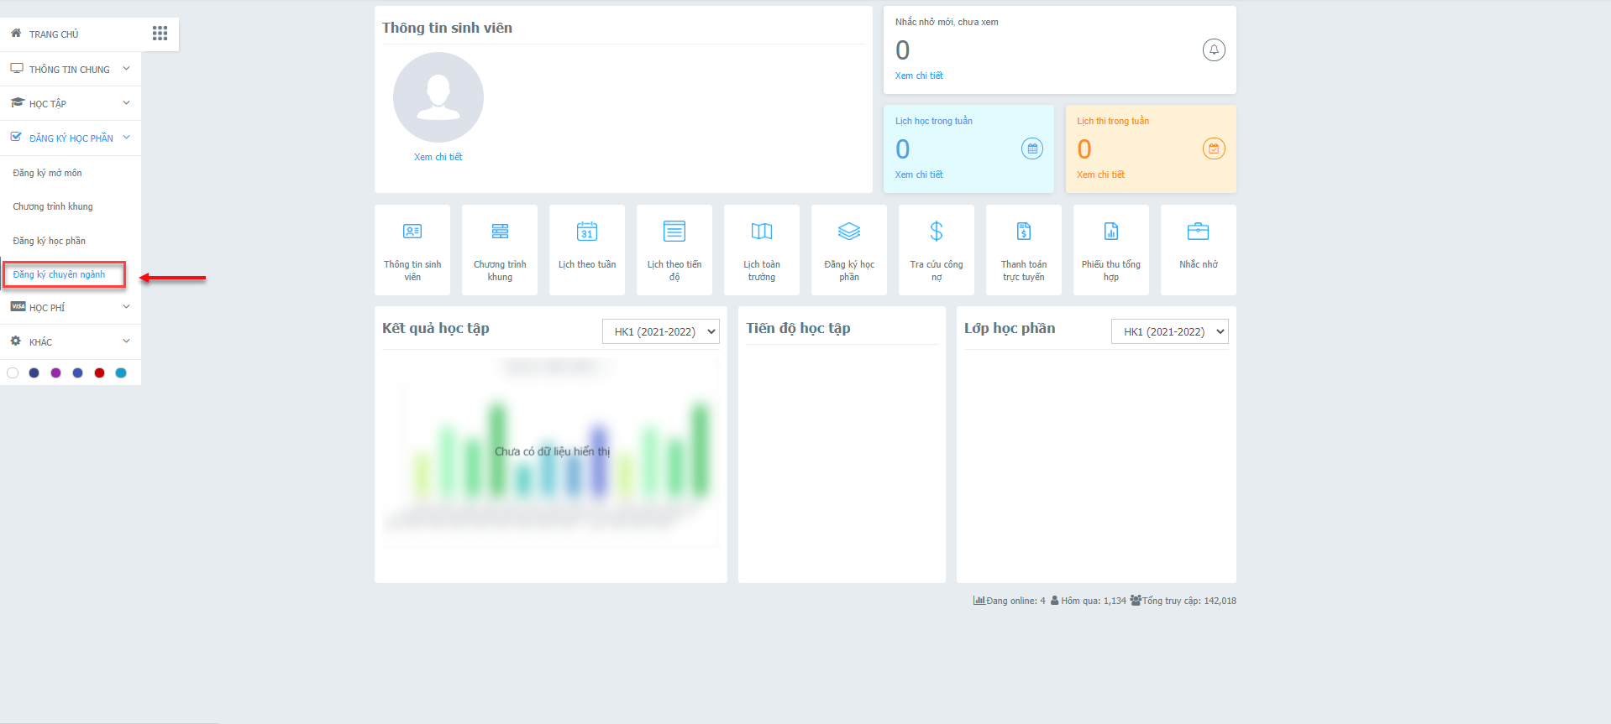

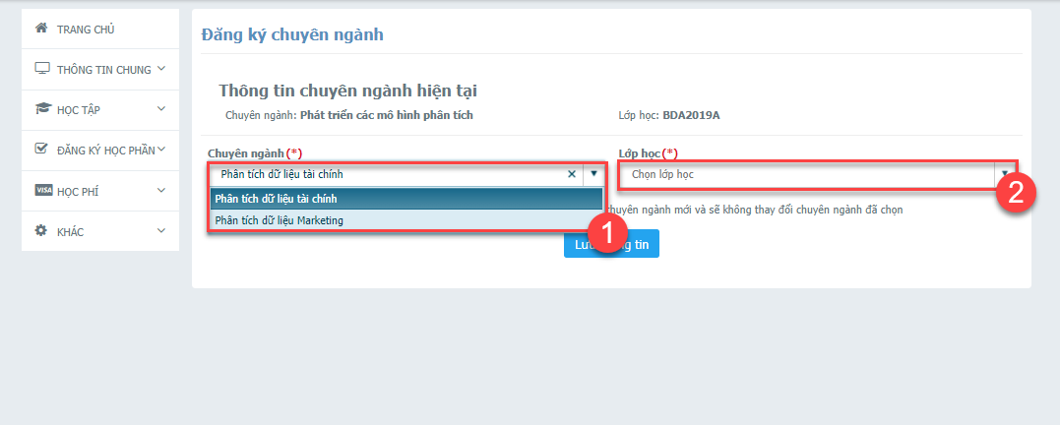
- The official selection for the in-depth major is only displayed after OAA confirms on Portal
Note:
- In the opening time of the in-depth study of major registration, the Portal is only displayed as the photo above. Out of the registration time, the notification showed “You are not permitted to register for in-depth study of major”.
- Student is allowed to register once for each time of registration time.
- To ensure classroom management, when choosing a new in-depth study, students need to choose the correct class with a letter code symbol similar to their original class symbol, the only difference from the current class is the number character behind it. after. For example, when students in class IB2022A switch to a new orientation of Finance, they will choose a new class on the system, IB2022A 1, and are not allowed to choose IB2022B 1, IB2022C 1, etc.
- For students in section 1.2 of this Notice: This is the final selection of specialized orientation and will not be adjusted any more, so students need to carefully consider before choosing.

